Technical Proposal
Pilot Design, Development, Deployment, and Evaluation of a Conversational AI-Based Early Warning System for Farmers Using the Agvisely Platform
Prepared by: Riseup Labs


Table of Contents
1. Executive Summary 3
2. Understanding of the Assignment 3
3. Scope Alignment with ToR 3
4. Proposed Technical Approach 4
4.1 Core Approach Principles 4
4.2 Functional Components 4
4.3 Advisory Guardrails 4
5. Proposed Solution Architecture 5
6. Development Methodology 6
7. Deliverables 7
8. Proposed Technical Stack 8
10. Testing and Quality Assurance 8
11. Assumptions and Dependencies 9
12. Out of Scope 9
13. Conclusion 9

1. Executive Summary
This proposal presents a practical and scope-aligned technical approach for designing, developing, deploying, and evaluating a Bangla voice-based conversational AI early warning system for farmers using the Agvisely platform. The solution will enable farmers and extension officers to access weather forecasts, crop advisories for the required crops, and wheat disease forecast-based advisory information through a registered hotline number using basic mobile phones.
The proposed system is designed around inclusive access. Farmers with feature phones, limited internet connectivity, or low digital literacy will be able to call the hotline, ask questions in Bangla, and receive spoken responses generated only from approved Agvisely information and relevant wheat disease advisory content. The pilot will also collect evaluation data to assess usability, engagement, comprehension, trust, adoption of recommendations, and agricultural outcomes.

2. Understanding of the Assignment
The ToR identifies Agvisely as an existing climate-smart advisory platform that delivers localized weather forecasts and agricultural advisories. The key gap is that many farmers do not have smartphones, stable mobile internet, or sufficient digital literacy to directly use the mobile application. Therefore, the required solution must extend access through a Bangla voice-based channel that works over basic mobile phones.
- Develop a Bangla conversational AI voice interface linked with Agvisely.
- Create and configure a hotline number to access the system.
- Integrate weather forecasts, agricultural advisories for 10 crops, and crop disease warnings from available Agvisely information.
- Include wheat disease forecast-based pre-season advisory information as a static advisory source.
- Deploy and validate the advisory service with at least 1,000 farmers and extension officers.
- Collect evaluation data on engagement, comprehension, trust, adoption of recommended practices, and agricultural outcomes.
- Prepare system architecture, design documentation, and a final project report.

3. Scope Alignment with ToR
ToR Requirement | Proposed Response | Scope Control
Bangla conversational AI voice system | Build a voice-based conversation layer with Bangla speech recognition, scoped dialogue handling, and Bangla voice response. | Limited to advisory use cases defined in the ToR.
Hotline number access | Register/configure a hotline number and connect it to the IVR/call control gateway. | No smartphone app redevelopment included.
Agvisely API integration | Integrate with Agvisely backend/API for location-specific weather and crop advisory retrieval. | Responses will be generated only from available Agvisely information.
Weather, crop advisory and disease warning | Support weather forecasts, agricultural advisories for 10 crops, and crop disease warning information. | No additional crop intelligence beyond approved sources.
Wheat disease forecast-based advisory | Add a static advisory source for pre-season wheat disease forecast information. | Static content management only for the required advisory source.
Pilot deployment to at least 1,000 users | Support pilot outreach, call usage, advisory delivery and monitoring for 1,000 farmers and extension officers. | Pilot scale only, not national production scale.
Evaluation framework | Capture automated survey responses and usage metrics for engagement, comprehension, trust, adoption and outcomes. | Evaluation reporting only; no large analytics platform expansion.

4. Proposed Technical Approach
The technical approach focuses on a lightweight, reliable, and pilot-ready system that can be integrated with Agvisely without rebuilding the existing platform. The core design is a phone-based advisory channel powered by a scoped conversational AI layer and Agvisely API integration.

4.1 Core Approach Principles
- Phone-first access: farmers can use basic mobile phones through a registered hotline number.
- Bangla-first conversation: voice input and voice response will be handled in Bangla to reduce digital literacy barriers.
- Agvisely-grounded answers: the AI response will be generated only from Agvisely advisory data and approved wheat disease advisory content.
- Low-bandwidth operation: all farmer-side interaction will happen through voice calls, avoiding dependency on mobile internet.
- Pilot-focused implementation: the system will be designed for controlled deployment, monitoring, bug fixing and evaluation data collection.
- Evaluation-ready data design: usage and survey data will be structured from the beginning to support final reporting.

4.2 Functional Components
Component | Purpose | Key Notes
Hotline / IVR Gateway | Receives calls from farmers and extension officers and connects the call to the voice AI system. | Configured for inbound calls, session handling and basic call logs.
Bangla Speech Layer | Converts Bangla speech into text and converts advisory response text back into Bangla voice. | Speech quality will be tested using representative farmer queries.
Conversation Agent | Understands user intent, asks for required context and structures the advisory query. | Conversation will remain limited to weather, crop advisory and disease warning scope.
Advisory Orchestrator | Connects the AI layer with Agvisely API and wheat disease advisory content. | Ensures source-grounded responses and handles missing data gracefully.
Evaluation Data Layer | Stores call metadata, advisory topic, survey responses and pilot evaluation data. | Used for monitoring and final project reporting.
Operational Monitoring | Tracks service availability, failed calls, response quality issues and pilot progress. | Lightweight monitoring for pilot management only.

4.3 Advisory Guardrails
- The system will not provide unverified agricultural recommendations outside the approved Agvisely and wheat disease advisory sources.
- If required information is unavailable for a crop, location or topic, the system will provide a clear fallback response and may suggest contacting an extension officer.
- All generated responses will be logged in structured form for quality review during the pilot period.
- The response templates will be designed to be short, understandable and suitable for voice delivery.

5. Proposed Solution Architecture
The proposed architecture keeps the existing Agvisely platform as the authoritative advisory source and adds a voice access layer, conversation layer and pilot evaluation layer around it.
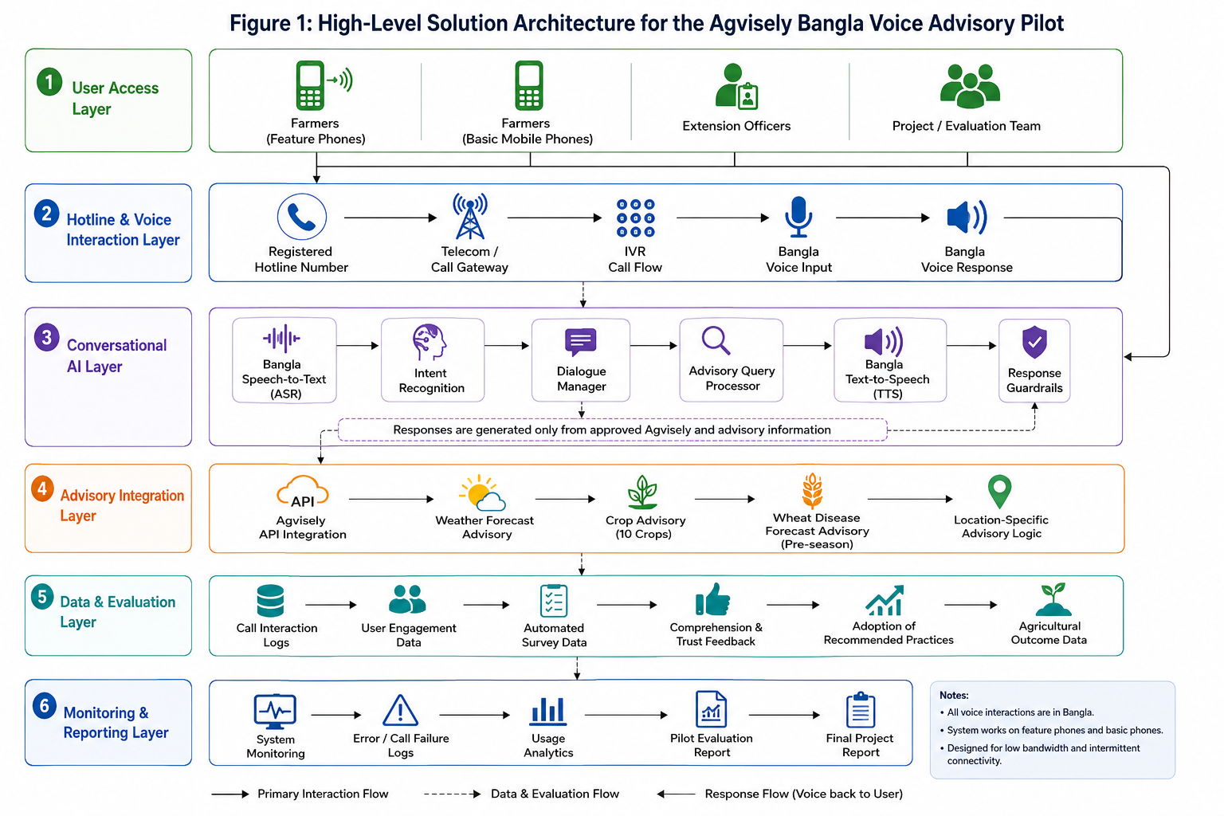

Figure 1: High-Level Solution Architecture for the Agvisely Bangla Voice Advisory Pilot

The following flow shows how a user call will move from hotline access to voice processing, advisory retrieval, voice response and evaluation data capture.
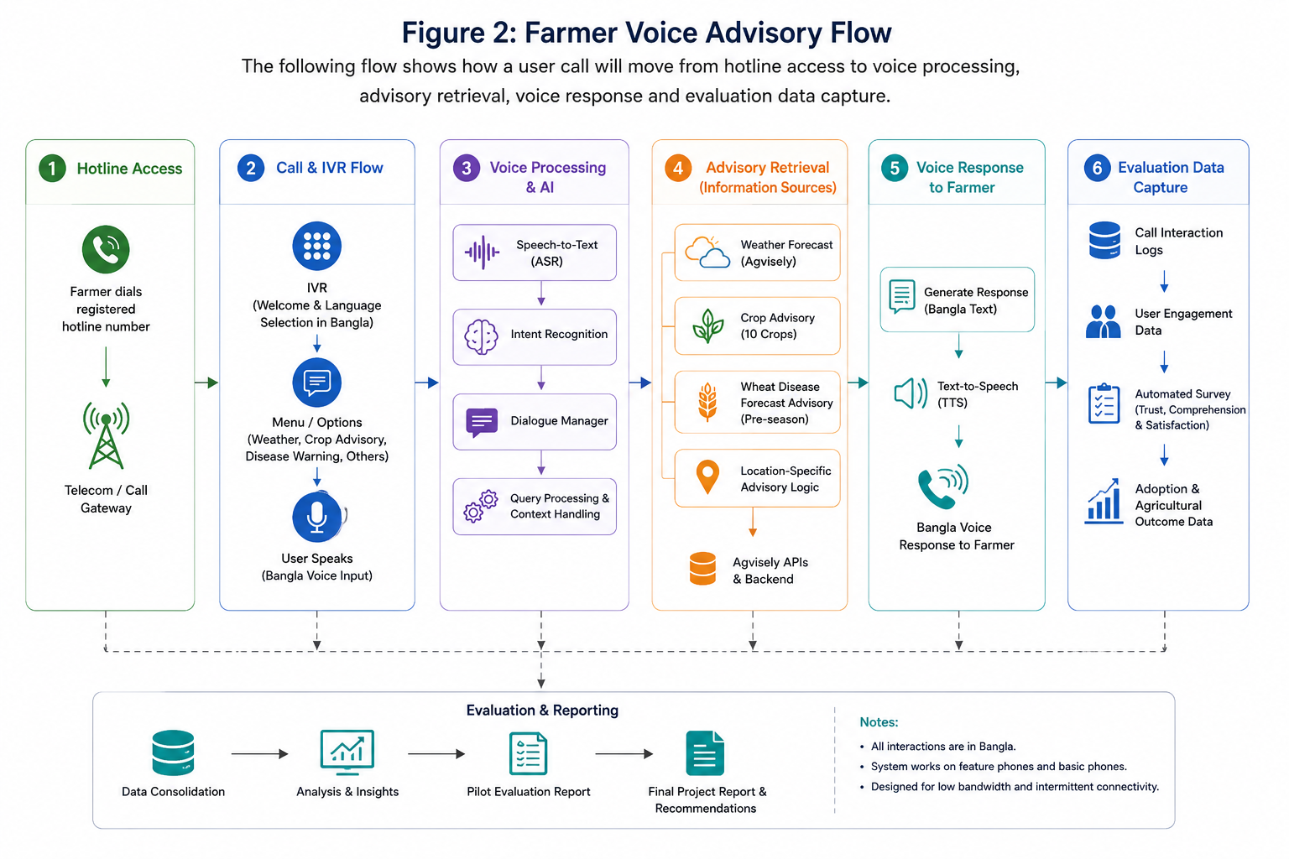

Figure 2: Farmer Voice Advisory Flow

6. Development Methodology
A controlled agile delivery methodology is recommended because the solution combines telephony, Bangla voice AI, API integration and field-level validation. The work will be organized into short design-build-test cycles while staying aligned with the ToR timeline.
Phase | Main Activities | Outputs | ToR Alignment
1. Discovery and Design | Confirm user needs, call flows, advisory categories, Agvisely API access, wheat advisory content, evaluation metrics and deployment constraints. | Requirement confirmation, voice flow, architecture and evaluation plan. | System design and user need assessment.
2. Prototype Development | Develop hotline integration, Bangla speech layer, conversation logic, advisory orchestration and data capture modules. | Working prototype ready for integration testing. | Functional Bangla conversational AI prototype.
3. Integration and QA | Integrate with Agvisely API, test advisory retrieval, validate voice responses and complete pilot readiness testing. | Integrated and tested pilot version. | Development and integration with Agvisely.
4. Pilot Deployment | Deploy to target farmers and extension officers, monitor usage, capture survey data and resolve system bugs. | Pilot service operation and monitoring dataset. | Pilot deployment and monitoring.
5. Evaluation and Reporting | Analyze usage, comprehension, trust, adoption and outcome data; document findings and improvement areas. | Final project report and technical documentation. | Evaluation data and final project report.

7. Deliverables
Deliverable | Description | Acceptance Focus
Bangla Conversational AI Voice Prototype | Functional prototype that allows farmers to ask advisory-related questions in Bangla and receive voice responses. | Successful end-to-end call and advisory response flow.
Hotline Number Setup | Registered/configured hotline number connected to the IVR/call control layer. | Users can access the system from basic mobile phones.
Agvisely Integration | Integration with Agvisely API for weather forecasts, crop advisories and disease warning information. | Advisories retrieved from approved Agvisely sources.
Wheat Disease Advisory Integration | Static pre-season wheat disease advisory content made available to the conversation system. | Wheat-related query returns approved advisory information.
Pilot Advisory Delivery | Advisory delivery to at least 1,000 farmers and extension officers during the pilot period. | Pilot usage records demonstrate outreach and service usage.
Evaluation Data Collection | Automated survey and logs covering engagement, comprehension, trust, adoption and agricultural outcomes. | Structured dataset ready for analysis.
Architecture and Design Documentation | Documentation of system architecture, call flow, API integration, data model, deployment and guardrails. | Clear technical documentation for review and handover.
Final Project Report | Pilot implementation summary, evaluation findings, system performance observations and recommendations. | Complete report aligned with ToR evaluation objectives.

8. Proposed Technical Stack
The technical stack below is proposed to support a pilot-grade, maintainable and integration-friendly solution.
Layer | Recommended Technology / Option | Purpose
Telephony / Hotline | SIP trunk with Asterisk or FreeSWITCH / IVR gateway | Inbound hotline calls, call routing, call session handling and telephony integration.
Backend API | Python FastAPI | Conversation orchestration, Agvisely API integration, survey capture and internal service APIs.
Bangla Speech-to-Text | Bangla-capable ASR engine such as Whisper-based service or equivalent approved STT engine | Convert farmer voice query into text for conversation processing.
Bangla Text-to-Speech | Bangla-capable TTS engine or approved local/cloud TTS service | Convert advisory response into spoken Bangla.
Conversation Logic | LLM/RAG-style scoped response generation with rule-based guardrails | Generate concise, source-grounded Bangla responses based only on approved advisory data.
Integration | REST/JSON API integration with Agvisely backend | Retrieve location-specific weather forecasts and crop advisory information.
Database | PostgreSQL | Store user call records, advisory topic logs and evaluation/survey responses.
Cache / Queue | Redis | Manage short-lived sessions, retries and lightweight background tasks.
Deployment | Docker on Linux server or approved cloud/hosting environment | Reliable pilot deployment and simplified maintenance.
Monitoring | Application logs, call logs and lightweight exports | Track pilot usage, failed calls, response issues and evaluation readiness.
Final technology selection should be confirmed after reviewing Agvisely API availability, hosting constraints, preferred telephony provider, data protection requirements and Bangla voice engine performance.

10. Testing and Quality Assurance
The QA plan will focus on validating the functional, integration, voice, performance and field-readiness aspects required for the pilot.
QA Area | QA Points
Functional Testing | Validate call connection, query capture, advisory retrieval, voice response, survey collection and call completion scenarios.
Agvisely API Integration Testing | Verify API authentication, request/response mapping, error handling, unavailable data handling and advisory accuracy against approved source data.
Bangla Voice Quality Testing | Test common farmer questions, local pronunciation variations, background noise scenarios and clarity of spoken response.
Scope and Guardrail Testing | Confirm that the system does not provide recommendations outside Agvisely/wheat advisory information and uses fallback responses when needed.
Feature Phone / Low-Bandwidth Testing | Test access from basic mobile phones, unstable call quality and real telephony network conditions.
Pilot Load Testing | Validate expected call volume, concurrent call handling, queueing behavior and service stability during pilot usage.
Data Quality Testing | Check completeness and consistency of engagement logs, survey responses, advisory categories and evaluation fields.
Security and Privacy Checks | Validate secure API access, restricted admin access, safe data storage and avoidance of unnecessary personal data collection.
User Acceptance Testing | Conduct sample UAT with representative farmers and extension officers before broad pilot rollout.
Regression Testing | Re-test major call flows after bug fixes, API changes or speech model adjustments during the pilot.

11. Assumptions and Dependencies
- Agvisely API access, documentation and sample data will be provided before integration begins.
- The list of 10 crops and exact advisory categories will be confirmed by CIMMYT/Agvisely stakeholders.
- Approved wheat disease forecast-based advisory content will be provided in a structured or reviewable format.
- Hotline number registration, telco/SIP connectivity and call cost arrangements will be supported by the client or confirmed telecom partner.
- Pilot farmer/extension officer list, outreach support and field coordination will be arranged by the project stakeholders.
- Data collection requirements, consent wording and evaluation survey questions will be finalized with CIMMYT before pilot deployment.
- Hosting environment, data retention rules and administrative access requirements will be confirmed before deployment.
- Third party Ai integrations, TTS, Servers, Token cost and all the other third party services costing will be handled by the client.

12. Out of Scope
- Redevelopment of the existing Agvisely mobile application or web platform.
- Development of new crop advisory algorithms beyond available Agvisely information and approved wheat disease advisory content.
- Large-scale national rollout beyond the pilot users defined in the ToR.
- Advanced analytics, machine learning model training for new agricultural predictions, or external data marketplace integration.
- Full CRM, mobile app, farmer registration portal or payment-related modules.

13. Conclusion
The proposed solution provides a focused and practical path to extend Agvisely advisory access to farmers who may not have smartphones, internet access or high digital literacy. By combining hotline access, Bangla voice interaction, Agvisely-grounded advisory retrieval and structured pilot evaluation, the system can validate whether conversational AI can improve inclusive access to climate information and early warning services for farmers in Bangladesh.
The proposal remains closely aligned with the ToR by focusing only on the required voice advisory prototype, hotline setup, Agvisely integration, disease warning support, pilot delivery, evaluation data collection, documentation and final reporting.

